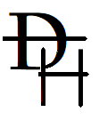
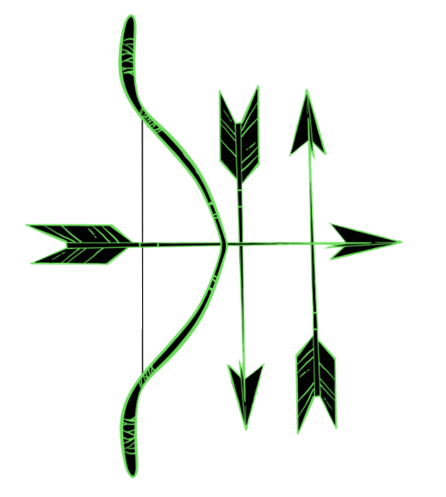
Destiny Hunter
A real-time action-packed multi-stage adventure RPG game!

Programmed and produced by Steve Lewis – April 2021
contact.steve.usa@gmail.com
Copyright © 2021 voidstar technologies
Compatible with any physical 32K Commodore PET 20XX, 30XX, 40XX (via cassette, floppy disk, or SD-drive emulator), the VICE emulator, or the online PET emulator available at https://www.masswerk.at/pet/

NOTE: When responding to the initial request to “Press RETURN” the program will use the resulting keycode to detect the type of keyboard configuration in use, and thereafter adapt accordingly. Should you encounter any keyboard-compatibility issues, please contact me and we’ll resolve the issue. As for making an 80-column compatible version, such an enhancement is possible, but would impact the game performance at the same clock speed.

Gameplay Keyboard Instructions
4 / 6 Rotate Weapon Left/Right
W/A/S/D Move your character UP/LEFT/DOWN/RIGHT
B Invoke use of a BLESSING
NUMPAD-0 Reinforce your PERSISTENCE (recovers health)
SPACE Fires an arrow
P Pause the game (press RETURN to resume)
HINT: There are some additional keys that may be unlocked throughout your adventure!

Introduction
Destiny Hunter (DH) is a story-adventure game developed to honor the original 8-bit Personal Computer: the Commodore PET. The story is told through a sequence of related STAGES that contain CHALLENGES. The theme of the story involves hunting with a bow within a dream. By being a dream-story, the CHALLENGES take on the form of mythical creatures.
In homage to 8-bit computing, you will see “8” in various places: eight stages, eight chimes, eight directions of firing, the 8x8 taijitu in STAGE 4, etc.
In its technical development, an additional goal with DH was to demonstrate the potential that these early Personal Computer devices had “out of the box” relative to that year of release: 1977. As such, the four primary technical constraints were: (1) be loadable from a tape cassette, (2) use no more than 32K RAM, (3) operate at 40x25 resolution, and (4) require no specialized socket ROM or external support (which implies operating with the standard 1MHz 6502 clock rate). DH has met all of these constraints, so that it can function in the online Commodore PET 2001 emulator.
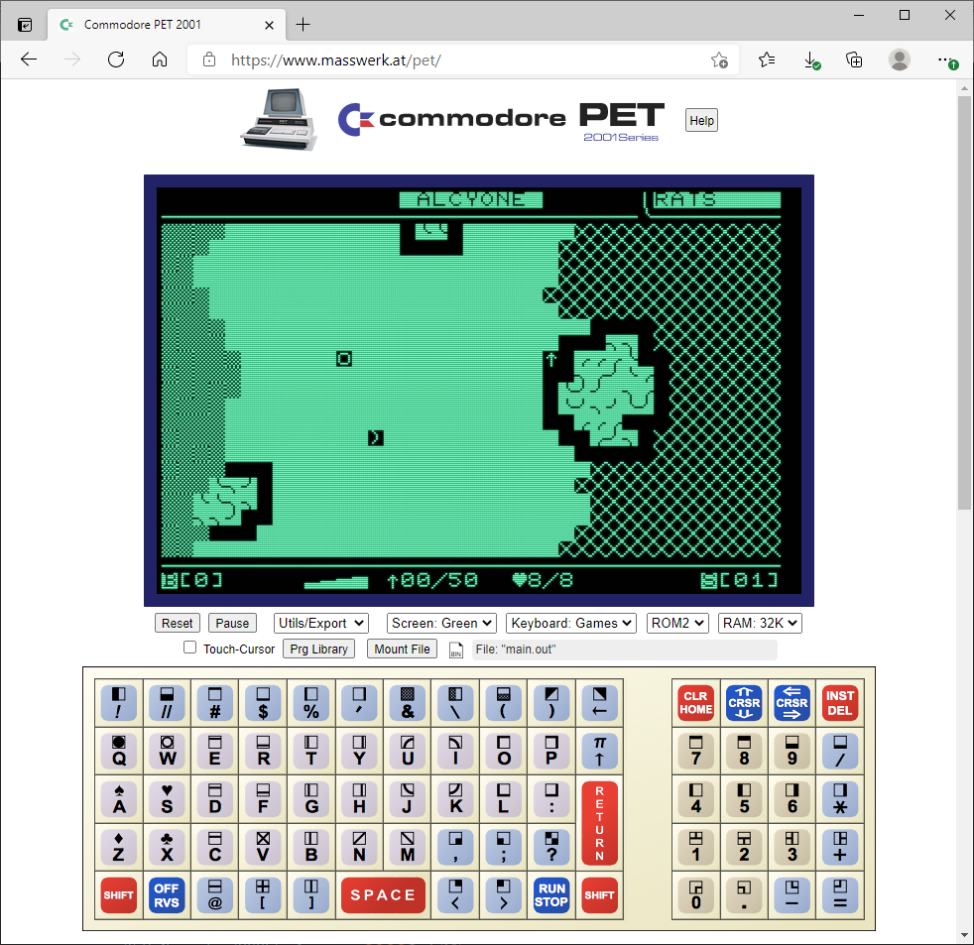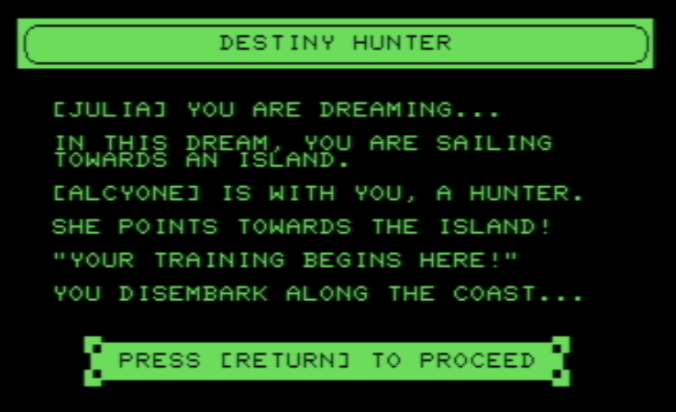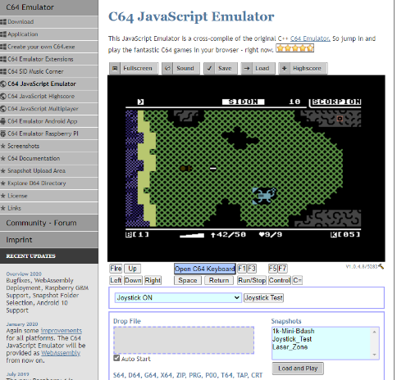

In terms of game design constraints: several variations of typical single-screen one-direction shooter type games were considered, like Centipede, Space Invaders, or even Tetris. But DH quickly evolved to become more of an “interactive story” and from there into a “real time action adventure” with RPG elements. DH is scoped to about a 10 minute play-duration, but uses nearly every bit of RAM to pack the experience into the available 32K address space of the Commodore PET system. To be standalone, the game must “contain its data” internally. This is why text-message content within the game is sparse, they are a luxury within a system that has very limited resources to spare for digital-to-human translations.
I consider the development of Personal Computing fascinating, since it represented the birth of an entirely new form of media: Software. Akin to the development of writing itself: The use of binary mathematics and logical operators to express ideas and information (content)! Those of us born in the 1970s are the last human generation to know the world BEFORE mass-computers. We stood during a final moment that, centuries later, will be considered like the hand-paintings in caves from centuries before: very humble and primitive beginnings, but yet an important juncture in the journey of humankind.

Character Creation
When you begin Destiny Hunter, you first establish the DIRECTION of your character. You will see a flickering of motion across near the top of screen, representing the fates molding your DIRECTION. The speed is so intense, you cannot reliably predict what your DIRECTION will end up being. The selection is categorized as being either YONI or LANGI. While the selection does alter aspects of your adventure experience, the overall challenge will remain the same regardless of the result. To indicate the direction that was decided, simply press SPACEBAR at any time.
The next aspect of character creation is called the CHIMES. These chimes represent eight spirits that are encountered along the passage of your character being created. These spirits are acknowledged by ringing their corresponding chime, which is also done by pressing SPACEBAR. Typically, the respect you have shown by ringing a chime is acknowledged and you simply proceed to the next one. But sometimes, an interesting thing can happen: the spirit may award you a BLESSING. Such a spirit may initially be reluctant on deciding if you are worthy of such a gift, and may insist that you ring the chime again. These manifest as AGAIN chances.
You receive a PERSISTENCY for each AGAIN chance. Should you become weakened during your adventure, use PERSISTENCY to recover your health, giving you the willpower to endure. As for BLESSINGS, their purpose is said to be related to the bending of time, and they are quite rare and valuable. BLESSINGS can only be obtained from these spirits, whereas conquering CHALLENGES will award arrows and PERSISTENCY.
Once you have rung all the CHIMES, you will see a tally of your BLESSING and PERSISTENCY. The final step of character creation is to accept these results (by pressing RETURN), or to try again (press X).
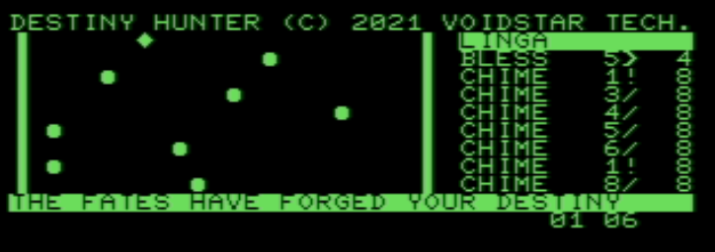
The above is an example of a typical character start: There were two AGAINs (indicated by the “1!”) and one BLESSING, where the BLESSING also
includes N-1 PERSISTENCY (in this example, 1+1+(5-1) = 6 total PERSISTENCY awarded for the initial STAGE.

Persona Selection
After Character Creation, the next task is Persona Selection. The ancestor to your character is one of these chosen personas, all of whom were extraordinary hunters from the past.

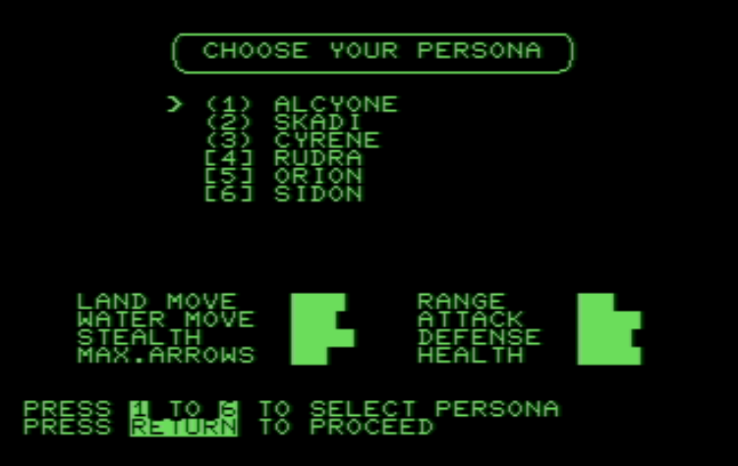
HINT: The YONI DIRECTION tends to have soft edges while the LANGI DIRECTION is more squared.

You can press 1, 2, 3, 4, 5, 6 to select a persona. Upon doing so, you will see an updated graph on various STATS correspond to the highlighted persona. A longer graph for any specific STAT indicates greater strength in that STAT. Each persona will have a unique set of strengths and weaknesses, which will alter the nature of your encounter with the CHALLENGES. ALCYONE is considered the “normal” difficulty and the others have relative strengths and weaknesses.

The STATS are described as follows:
LAND MOVE: Indicates the personas rate of mobility within map terrain that is not water.
WATER MOVE: Indicates the personas rate of mobility within water portions of the terrain. Typically water movement is more difficult and slower.
STEALTH: A higher stealth corresponds to a greater chance of not being sensed by CHALLENGES, due to moving more quietly.
MAX.ARROWS: Indicates the maximum number of arrows this persona can carry at once. Collecting more arrows while already at the maximum will waste that collection.
RANGE: Corresponds to how far this persona can fire an arrow.
ATTACK: When a CHALLENGE is attacked, this stat is used to determine if that attack is successful (corresponding to the personas proficiency and precision at using a bow). A higher graph corresponds a larger chance of success at hitting a CHALLENGE.
DEFENSE: Likewise, when a CHALLENGE attacks you, this stat corresponds to your agility and overall ability to dodge that attack. A higher graph corresponds to a larger chance of success at avoiding the attack.
HEALTH: This graph is the maximum health this persona has, representing their overall constitution. Personas with lower health will need to rely on PERSISTENCE more often.
Your character will inherit these same stats from the chosen persona. Designate a chosen persona and then make the selection by pressing RETURN. In case there was some doubt on the selection, you can then press X to cancel that selection. Otherwise, you must press RETURN a second time to confirm the selection.

Navigating Stages
Once you have made your persona selection, you then begin your adventure via a series of STAGES. There are eight total STAGES, one of which is an optional (but beneficial) flashback portion of the story.

HINTS
1 BEACH BOW RATS PICK UP BOW AND SEARCH THE GRASS AREA
2 NEAR LAND KOMODO HE DOESN’T WANT ANYONE ELSE NEAR THE WATER
3 RIVER GEM CROCS SPECIAL GEM ON ISLAND REVEALS SOMETHING…
4 (ISLAND) * STRIXES (YOU CAN’T DIE ON THIS STAGE, IT IS A PERSONA FLASHBACK)
5 ENTRANCE SCORPION SEARCH CAREFULLY BEFORE FINISHING
C64 VERSION: BEWARE OF THE EDGES
6 CAVE SLUAGHS SLUAGHS ARE HELL’S REJECTS; THEY SERVE THE HYDRA!
7 FAR LAND DRAKES GUARDIANS OF THE HYDRA (C64 VERSION: A SURPRISE!)
8 MOUNTAIN (mystery) BONES OF PAST HYDRAS ON THE RIGHT SIDE
THE BEACH IS SAFE
* OPTIONAL (curious players may unlock the puzzle that transports to this stage)
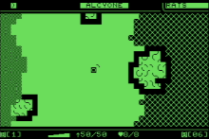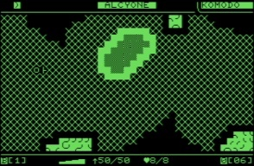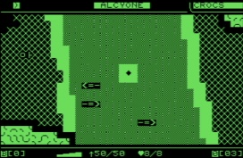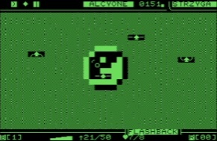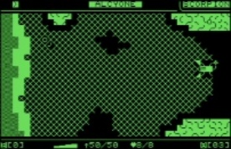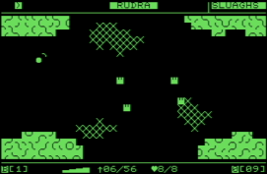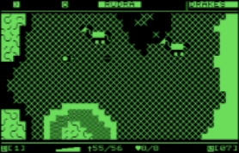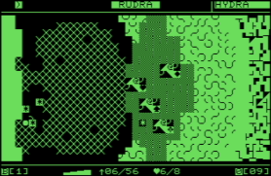
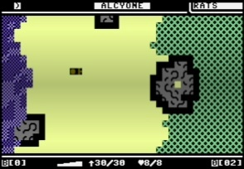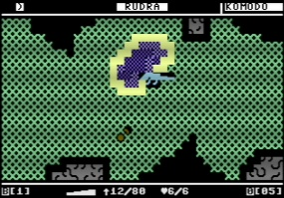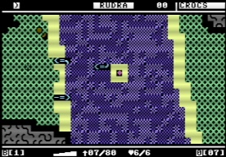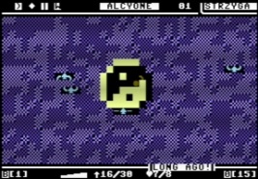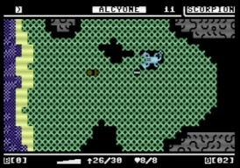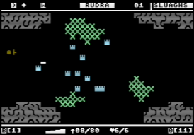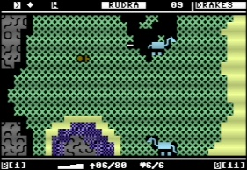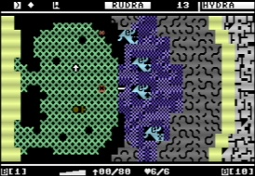
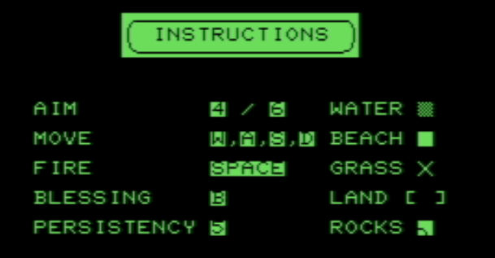
NOTE: the Commodore PET did not have four distinct Arrow Keys; instead moving back or up was interpreted as the “reverse” of forward and down, thus the PET offered only two distinct Arrow Keys with a SHIFT mode. For this reason, the choice was made not to rely on arrow keys for movement.

Terrain
The map of each STAGE has several types of terrain: WATER, BEACH, GRASS, ROCKS, LAND (and several SPECIAL types). Your character will consume more energy moving across WATER. BEACH, GRASS, and LAND are each essentially the same, just different brightness (full, partial, none respectively). ROCK terrain is typically BLOCKED, meaning you (and CHALLENGES) cannot move into (or fire over) a ROCK terrain. You may witness some exceptions to these descriptions, since the land is enchanted!
Arrows
To finish a stage and proceed to the next one, you must defeat all the CHALLENGES within that stage. This is done by firing arrows with a bow collected on the beach within the first stage. Arrows are fired by pressing SPACEBAR, but aim with care as arrows are limited in quantity (and only one arrow at a time may be fired).
Should you run out of arrows, the spirits will gift a new set of arrows. However, this gift will be placed randomly per each STAGE, thus likely losing your initiative and position by having to go collect those arrows. This gift is depicted as an UP-ARROW icon. When you defeat CHALLENGES, they will become LEFT-ARROW icons, indicating that you may go to those position to also collect additional arrows.
HINT: The spirits gift of arrows will appear ONLY when you have “00” arrows (none). The gift generally provides more arrows than the CHALLENGES, therefore it is wise to collect the UP-ARROW gift arrows first before the CHALLENGE dropped LEFT-ARROWs (depending on your battle situation).
Stamina and REST
As you move around within a stage, you will exert energy and lose STAMINA. Firing the bow also consumes energy. You will recharge your energy over time automatically, but if exhausting too much stamina too quickly, you will be forced to REST. You must recover a minimum amount of STAMINA before the REST is complete, therefore do not continue to exert yourself while in REST mode.

Overview of Stage Layout
The stage map is overlayed at the top and bottom with information to aid you during your adventure.
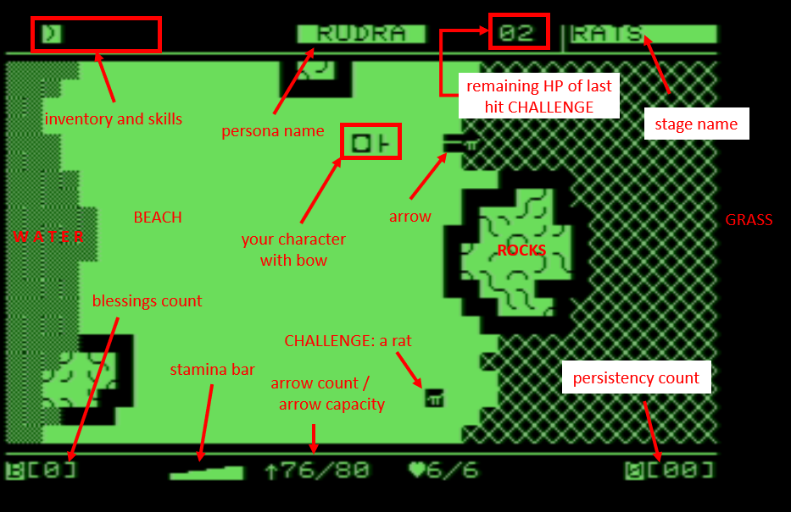

Final Words
As a hunter, you will need to exercise patience when targeting the challenges. An arrow can miss, especially if the challenge is moving at the time. Challenges will move throughout the stage somewhat randomly, but will also occasionally loiter for brief times. As a general hint, aim for the body, not the feet.
You can aim by rotating your bow around you, using the J and L keys.
A BLESSING is issued by pressing B, while PERSISTENCE is used by pressing NUMPAD-0. Like arrows, these options are limited in quantity. The quantity remaining is shown across the bottom of the STAGE.
When all challenges are defeated, you will be prompted to press F to proceed to the next stage. Before doing so, be sure to recover arrows from defeated CHALLENGES.
Heed this final advise: There is said to be an orb lost within these lands. It was lost by a traveler long ago, who was unconcerned about it since he said that this orb had only one final usage remaining. What the orb would do he did not say, but the traveler was said to have excellent stamina!
Go forth adventurer! A great evil has awakened within the mountains of this island, seize your destiny to bring peace and serenity back to its inhabitants. May the guidance of your persona steady your aim!

JOYSTICK CONTROLS [ C64 VERSION ONLY ]
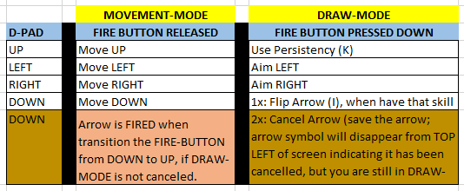
DH uses PORT 2 of the C64 joystick only. The controls may require a little bit of getting used, but will make sense once they are understood.
Use the joystick to MOVE the character, as expected (UP/LEFT/DOWN/RIGHT).
The important thing to know is: HOLD the FIRE button to DRAW your bow and prepare to FIRE. You will not actually fire until you RELEASE the FIRE button.
While you are DRAWING (holding) your BOW, you are in the DRAW-MODE and the UP/LEFT/DOWN/RIGHT now do something else. Double-Tap DOWN to cancel the ARROW FIRE, use LEFT/RIGHT to rotate the BOW, or press UP to use PERSISTENCY.

Credits and Special Thanks
The game programming, map design, and this documentation was done by Steve Lewis. Special Thanks to my wife and daughter, who provided real time feedback during the development. My daughter created the DH graphic logo.
Aspect of the game were inspired by Frogger, Zelda, Rygar, King’s Quest, and the Ultima-series.
Various tools were essential for the development of this media:
- cc65 (C compiler for 6502 and the corresponding assembler and linker)
- DirMaster (D64 reader for Windows), instrumental in facilitating access to the MapEditor output files to be pasted directly into the source code.
- notepad++ (the only editor used to write the source code)
- Microsoft Paint and the Microsoft Office suite (for creating my own PET Character Set reference sheets)
- VICE (Commodore C64 emulator)
Olaf Seiber’s 1994 newsgroup post on the “PET RAM memory map” provided technical information on useful kernel system calls to help speed up certain game functions, access the system clock, and enable the non-gap “graphics mode” of the PET. The c64-wiki provided useful C64 color and joystick address information.

Where’s the Sound
I originally wanted to include some aspect of audio in DH. Doing so is also a technical competence demonstration, since coordinating background music during a real-time game is a challenge. I did discover the process to do octave and frequencies on the Commodore PET, however this is a late-model feature only (40XX-series) and was not available on the original Commodore PET. Aside from this, as a completely standalone build, the game is quite full as it is in terms of what features it can include. Many features had to be reduced or removed (such as naming your character, a heartbeat indicator, the step indicator, box pushing puzzles, NPCs, traps, even the intro/ending scenes had to be cut).

Therefore, the PET version will likely never have sound, but it is being planned to be added in the C64 version.

Destiny Hunter Rulebook [S P O I L E R S]
The DIRECTION is cosmetic only (banner borders) but does affect which personas are available. However, the DOT position when pressing SPACE becomes a MOD_VALUE (1-10 inclusive). This MOD_VALUE is used in an ultra-secret formula that is applied during CHIMES, where that formula decides BLESS, AGAIN, or PASS conditions. The CHIMES are also used to determine a total SEED_VALUE that is passed into srand() to initialize the RNG. (DIRECTION got its name since it decided which direction the SEED_VALUE was accumulated: positive vs negative).
For advanced players interested in insight on the DH game mechanics…
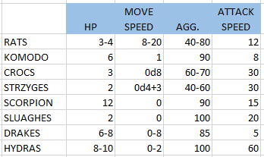
MAX. STAMINA = 1000
ACTUAL LAND MOVEMENT STAMINA COST = (9 – LAND) * 60
ACTUAL WATER MOVEMENT STAMINA COST = (9 – WATER) * 90
EVERY 1/8th SECOND REGENERATE 0d200 STAMINA (orb makes this fixed 300)
BOW STAMINA COST TO FIRE = (0d300)+100
MINIMUM STAMINA FOR ACTION = 100
(stamina can go negative, but a positive stamina is required to perform an action)
ACTIONS are MOVING and FIRING. Rotating bow does not cost stamina.
ACTUAL RANGE = RANGE * 2
ACTUAL DEFENSE IS INTERGER ROUND DIVIDED by 2. DEF = (DEF+1)/2 (e.g. DEF 8 DEF 4, DEF 5 DEF 3)
CHALLENGE HIT FAILURE IS: 0d10 < ACTUAL_DEFENSE
PLAYER HIT SUCCESS IS 0d10 < ATTACK
Keyboard commands are processed in two priority groups:
PRIORITY 1 is minimum 1/30th second delay: SPACE, P, B, O, 4, 6, 8, 5, NUM-PAD 0, F
PRIORITY 2 is minimum 1/15th second delay: W, A, S, D movement keys
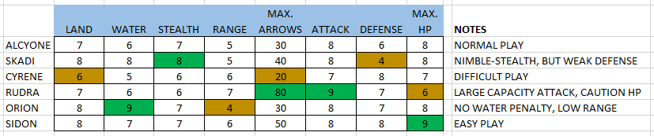
ACTUAL STEALTH = SENSE RANGE = ((9 – STEALTH)*2) – 1
(applied to all borders of CHALLENGE ICON, which are 5x3 cells at most)
The CHALLENGE MOVE and ATT. SPEED are “delay time” values, which means:
higher value is SLOWER. Generally, the attack speed is slower than movement
(these are 1/60th JIFFY counts; blessings DOUBLE these times {except 0 becomes 2}).
Higher HP is STRONGER Higher AGG is MORE FIERCE (more likely to chase).
CHALLENGES navigate up to 4 target points, some points are RNG.

When a CHALLENGE reaches a TARGET point, they RNG decide to: go to NEXT TARGET, go to PREVIOUS TARGET, go to RANDOM TARGET.

Before doing the next target decision, CHALLENGES always LOITER first. When LOITERING, may randomly move in X and Y for several cycles (0-10).

CHALLENGES attack only during the GOING state. If player enters SENSE region, there is a (0d100 < AGG) chance the CHALLENGE will chase the player (dynamic 5th target point) to their current position. (except fireballs do not chase).

When CHALLENGE HP reaches 0, they first become DEAD1 state on map (ARROW). Player may collect 1D10 arrows, which then transitions map tile to DEAD2 state (X).
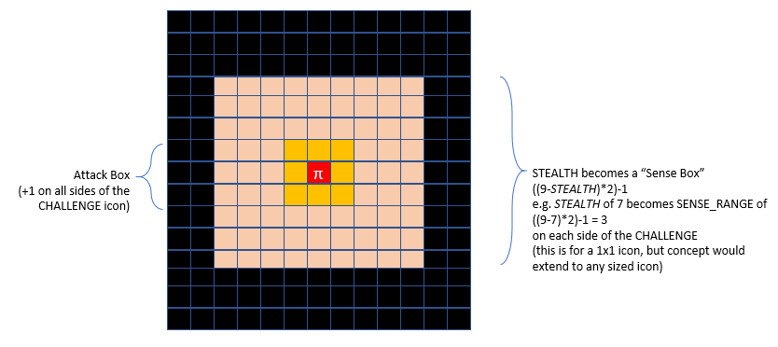

0dN means RNG 0 to N-1 (e.g. 0d5 means a value 0 to 4, inclusive)
1dN means RNG 0 to N (e.g. 1D10 means a value 1 to 10, inclusive)
For information on the animation effects, seek out my document
“a strategy for flicker-free heterogeneous multi-cell icon animation across a non-blank text-screen”

Technical Background and Details

The DH executable DHUNTER.PRG file is self-contained, which means the game contains both its own Data and its own Code. The advantage is that the program is easy to transport and load. Specifically, it can be loaded easily (linearly) via a tape, and does not require any complex or expensive external disk drive. This is similar to how some early arcade games operated, as the game needed to be accessible immediately, and requiring something like a disk drive was too impractical (slow access and moving parts are prone to wear and tear over time). Once the software development was perfected, an arcade game could be “burned to ROM” and set to be auto-loaded. However, the disadvantage is that this severely limits the scope of the game (how extensive it can be), since the presence of the “Data” reduces the amount of room for Code-Logic (as they both occupy the available address space of the system).

In 1977, disk drives were certainly available and understood, but had not yet been quite standardized and certainly weren’t yet affordable (nor reliable). While Personal Computing had arrived, they were still more akin to an interactive calculator, and it would be several years before disk drives were affordable and common place within the Home Computing environment. Therefore, this is why DH deliberately limits itself to that scope: a game that could have been experienced in an “out of the box” Commodore PET of late 1977.
The following page is a “memory map” of the DH software, which is intended to show why the game is limited to 8 stages, and that there is truly no room for expansion on the features of the program (aside from hardware changes; i.e. additional RAM, but the Commodore PET system was limited to 32K—and thankfully it had that much, as even this amount of RAM was quite a luxury in 1977).

Memory Map

DATA (~5.3K)
Map RLE Data and Blockers 1700 The compressed stage maps (3-bit type, 5-bit length; internal homage to 8-bit!)
MOD_DIV (4&8) Tables 120 Tables to quickly use MOD and DIV of 40 (screen width) to index into tables
Support Data 200 Stage names, feet/wing/pincher animations, initial arrow position per stage
Persona Data 120 Names, stats (att/def/stealth, etc.)
Challenge Data 800 Spawn locations, target points, initial health, aggressiveness, icon (3x5 max)
Screen Buffer 920 (23x40) Contains expanded RLE map content of current stage
Cell States Buffer 230 (23x10) 2-bit per character to mark animation draw-state
Text-Strings 1200 Translated English strings to communicate game-states to the player
STATE
Global Player Status 26 Location, weapon state, inventory, arrows/health/stamina remaining, blessing/persistence counts
Redraw Buffer 68 (34*2) Map positions to redraw (animation support)
CODE (20K)
Character Selection 1400 The DIRECTION and CHIME sequence
Persona Selection 1200 Selecting your persona
Introduction 700 Display Keyboard Controls and Map Legend
Stage Execution 9500 Drawing overlay, animation, AI challenges, main character movements, item management
End Game 600 Show steps, arrows, time, and Thank You
Utilities 5400 RLE decodes, write strings, clear screen, banners, PEEK keyboard/timer, multi-key code support

OTHER (~5K)
System Overhead 1300 System Reserved Addresses, C-compiler overhead, stack space
UNACCOUNTED FOR 4000

Story Development
I am not a hunter and I have never fired a bow. Initially I wanted a game mechanic where you had to DRAW the bow and that activated a RANGE indicator along your current direction, whereby you could OVER and UNDER shoot the target. But this resulted in a clunky TWO-PRESS action to fire, and at the resolution offered by the PET I just felt it wasn’t a fun experience (for example, I’d have to PAUSE the motion of the creatures while RANGING. I also realized: that’s not how hunting works. They don’t draw and aim at hundreds of feet, rather the action (with a bow) is often less than 30 feet. I confirmed this by watching various hunting videos on YouTube, where indeed the attack is a straight shot and not an arch. Originally the CHALLENGES in the game were all animals. Apparently hunting lions, bears, alligators, wolves are all a real thing. The trick is patience, but also aiming behind the front legs (for the heart or lungs). In the movie The Ghost and the Darkness (1996), hunting became a real necessity, as a pair of lions were attacking and eating a workforce that was building a bridge. But ultimately, I decided to change from traditional animals, and instead use “fantasy” oriented beasts.

Like an opera or a ballet, or a Vegas show, one generally has no idea what is going on without detailed background explanation. So, let us begin:

The STAGE 1 rats are purely for practice, although they can defeat you if sit still long enough. JACK is the younger rat that is faster and more aggressive, while the other rat is named JONAS.

STAGE 2 is a KOMODO DRAGON who is named JERRY. He is a long and narrow creature, so it is better to attack at an angle instead of head-on. These are real-things on the island of Madagascar and are quite fierce, known to eat a full-grown man.

STAGE 3 we debated quite a while on alligators, crocodiles, and gharial. Each of these are at our local zoo. Ultimately, I decided the gharial is a fish eater (and in fact we had in mind to add some fish as part of the CHALLENGES!). We compromise on just using CROCS, as in Nile River crocodiles. We didn’t name the CRCOS. But the final CHALLENGE here is a bird, who is one of the last surviving STRZYGA.

STAGE 4 is flashback to an epic battle in ancient times, enacted by your chosen persona. Once upon a time, that persona found themselves on Divinity Island having to face off against a sudden horde of STRZYGA! These are evil birds that are a cross between an owl and a bat. This situation was witnessed and ended up chronicled in a book, which can only be revealed by obtaining the Gem of Divinity (that you find in STAGE 3). Reading the book awards you a BLESSING, a very unique award indeed!

STAGE 5 is JAMES the scorpion, who considers the cave his nest. He’s quite aggressive, so be careful. [ in the C64 version, he has a brother named JUSTIN ]

STAGE 6 is where you enter the cave. Inside, you encounter a group of SLUAGHS! We considered Scottish folklore of Fachan (a single leg, single eye creature), as I liked the idea of a single strong arm (and we tried an animation where they had an arm from one side or the other). But I wanted to keep the creature to a single cell to maximize their speed. So, I settled on the Irish folklore of Sluaghs, a vile type of fae that travels in groups and desires only to take souls. One of the best descriptions I found is here: http://gotireland.com/2012/10/24/irish-faerie-folk-of-yore-and-yesterday-the-sluagh/

STAGE 7 leaves the cave and you find yourself pitted against two DRAKES, named JOSEPH and JIMMY. JOSEPH has a broken tail and moves more slowly. JIMMY, however, is the most aggressive CHALLENGE of them all, so be quite careful near him. If you defeat JOSEPH first, JIMMY goes even more nuts. [ in the C64 version, JUSTIN makes another surprise appearance here; he’s a stinker! ]

Finally, STAGE 8, the most epic battle of all: the HYDRA! We did not name each head of the HYDRA, instead we just collectively refer to her as JASMINE. See carefully that each head has a unique suite. The HEART is strongest. The fireballs can block your arrows. Technically these fireballs do have a health, but they are regenerated back to “99” during each firing. The heads themselves can attack, although at a slow rate. The ORB and a BLESSING make this easy work, if you got this far with them.

The story here is that the HYDRA is reborn every few centuries. What you see scattered along the right side of STAGE 8 are the bones of past HYDRAs. It’s a sad story: JASMINE is a triplet of three sisters who were cursed forever to perform this cycle of rebirth and enragement (due to having broken the heart of another maiden, who out of jealously then hired the services of a sorceress to conjure up this wicked enchantment for eternity). As it so happened, the JASMINE sisters had many pets, and these were cursed as well to become the CHALLENGES you see on this island (except the CROCS, STRZYGA and SLUAGH). Clearly, no way has been discovered to remove the curse, only that a brave adventurer must arise to place them all back to rest until the next cycle. But a merchant once claimed to have overhead these words from the traveler with the orb: “She lives!”

Upon putting the HYDRA back to rest, it is customary to speak out this haiku:

Be at peace again,
Till the next cycle begins,
You three are within.

YONI AND LANGI
These terms are essentially the Hindu version of Yin and Yang. While these words do not fully encompass the concept of male and female, one can think of Yoni/Yin as female and Langi/Yang as male. The concept here is that life is a balance, and when that balance is disrupted, typically a conflict will follow until the balance is restored. Perhaps certain things happen, as nature’s way of maintaining a balance. This balance includes diversity, as an essential ingredient to life, with the ultimate manifestation being that dichotomy of male and female egos. Not in an opposing fashion, but rather in a complementary way towards each other. Seek to balance out your virtues, such that one does not dominate the others.

